Playwright with type script Implementation
Prompt and Implementation:
Ask: Act as a senior architect and understand the entire project code. This will be useful for futher enhancement or changes in the project
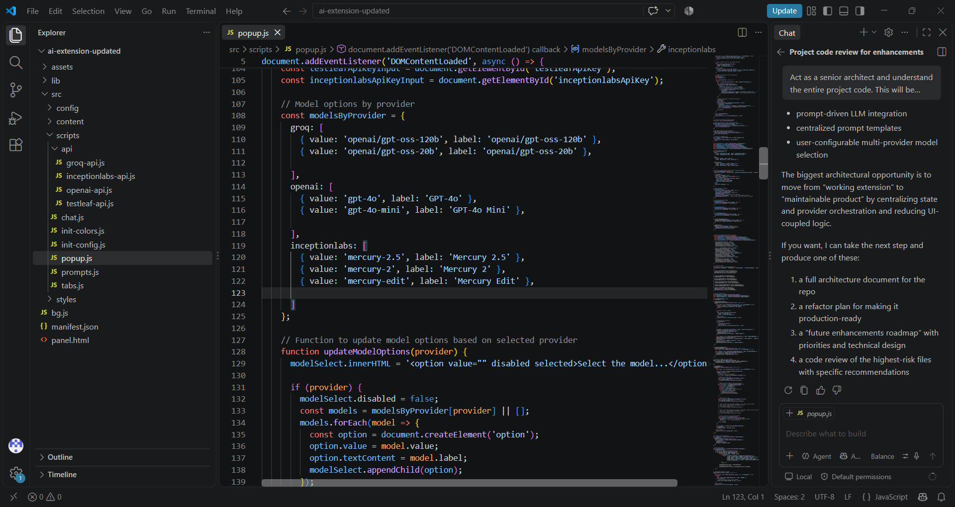
Plan: Project is having implementation for Selenium with java. When i select Language as Java and Selenium as Browser Engine in the Setting tab. Selenium with Java code is getting generated successfully. I want to implement for TypeScript as Selected Language and Playwright as Browser engine without impactiong the existing implementation for Selenium Java. Analyze the impacted files and fuctions. I need to review and approve. Then proceed with implementation in Agen mode Agent: Proceed with the implemention
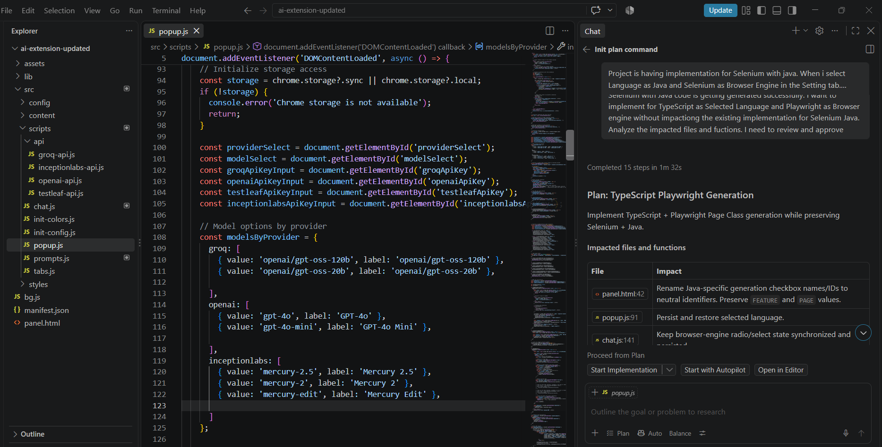
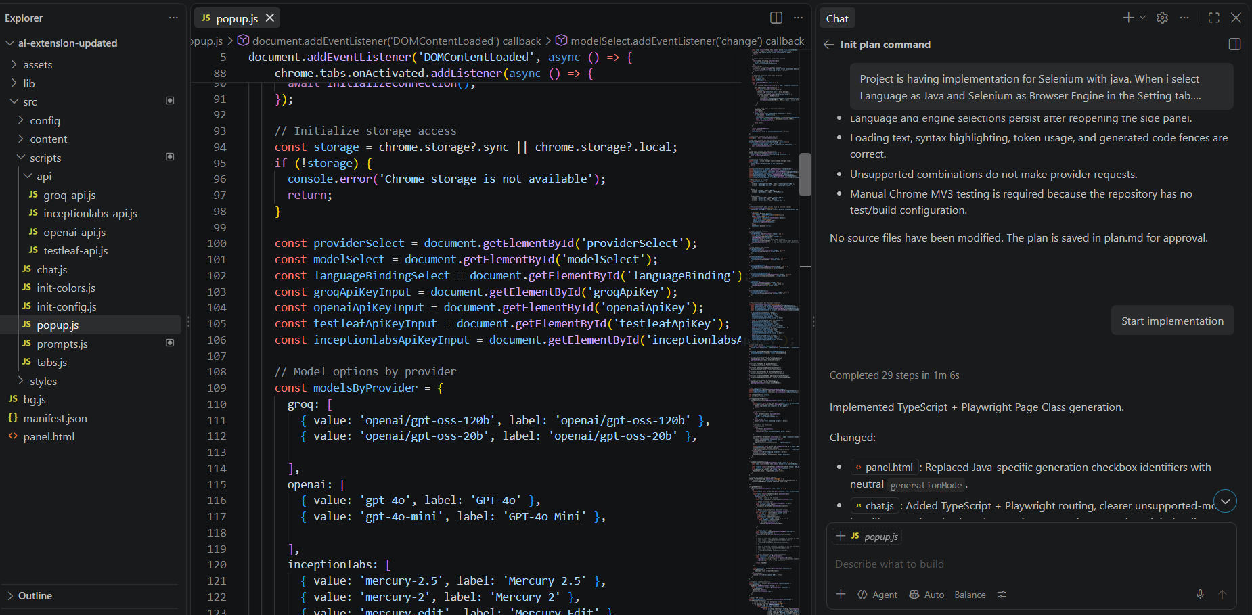

Ask: There are 3 models available under Select Model dropdown in the Settings tab. I want to add one more model. Analyze the code and provide me the class and function where i need to update the code
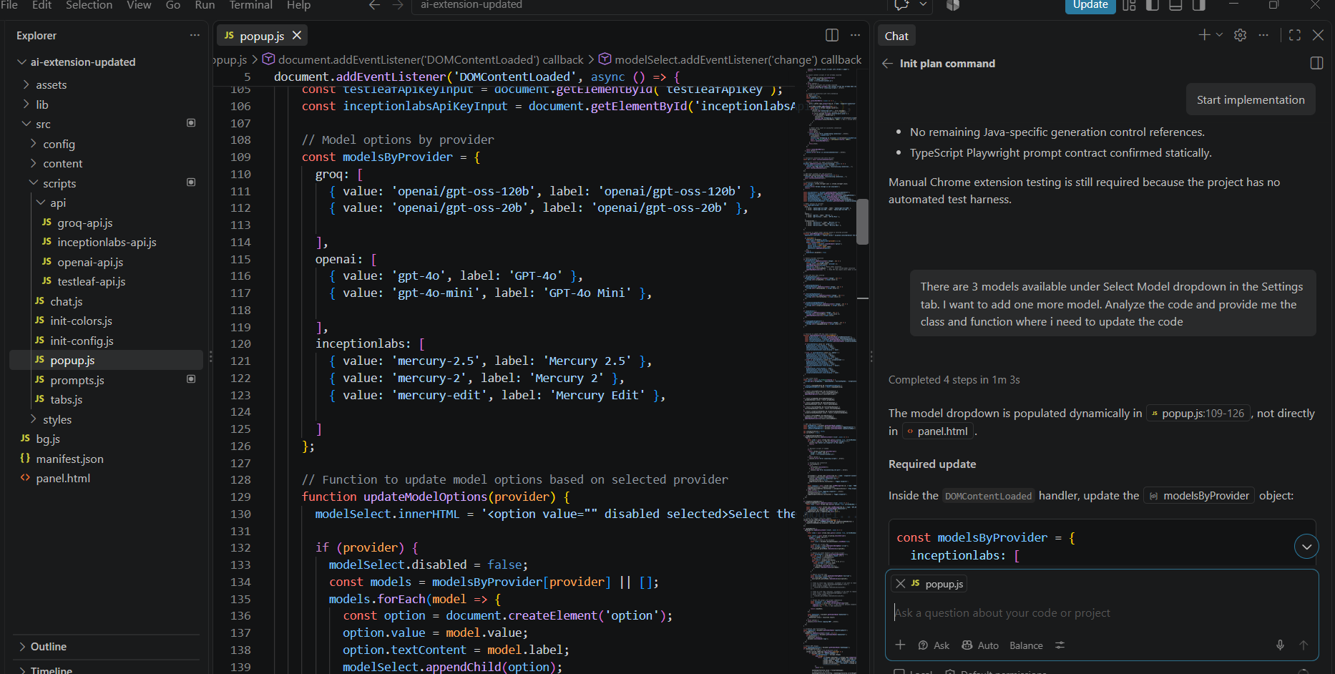
Use Ask Mode to analyze the existing project structure and identify all impacted files required for the Playwright with TypeScript implementation.
Once the analysis is complete, switch to Agent Mode to implement the required changes